A Variational Framework for Relational Quantum Phenomena and Cognitive Dynamics
Author: Jaba Tkemaladze
Affiliation: Longevity Clinic, Inc, Georgia
E-Mail: djabbat@gmail.com

Abstract:
This work presents a comprehensive theoretical framework, termed the "Inferential Collapse" (IC) model, which unifies principles from Relational Quantum Mechanics (RQM), active inference, and variational free energy minimization. The model re-conceptualizes quantum state reduction not as an observer-dependent "collapse" nor an ontological branching, but as a phase transition arising from a free-energy conflict between competing generative models within a relational network. We provide a complete mathematical formalization of this process, demonstrating its application to canonical quantum experiments, particularly matter-wave interferometry with macromolecules. We further propose a deep structural analogy between quantum dynamics and cognitive processes, suggesting that the inferential principles governing quantum coherence are isomorphic to those underlying perceptual transitions, dream states, and psychedelic experiences. The framework yields novel, testable predictions for both quantum physics and cognitive neuroscience.

Keywords: Relational Quantum Mechanics, Variational Free Energy, Active Inference, Quantum Measurement Problem, Decoherence, Cognitive Neuroscience, Psychedelics.

Introduction: The Need for an Inferential Turn in Quantum Foundations
The interpretation of quantum mechanics remains a foundational conundrum. The Copenhagen interpretation relies on an ill-defined divide between the quantum and classical realms, with a mysterious "collapse" of the wavefunction upon measurement (Bohr, 1928). The Many-Worlds Interpretation (MWI) avoids collapse but at the cost of an explosive ontological multiplicity (Everett, 1957; Vaidman, 2021). Relational Quantum Mechanics (RQM) offers a compelling alternative by positing that quantum states are not absolute but exist only relative to other systems (Rovelli, 1996; Smerlak & Rovelli, 2007). However, RQM has been criticized for lacking a formal dynamical mechanism to explain how relative facts become established through interactions (Goldstein, 2021).

Concurrently, in theoretical neuroscience and machine learning, the Active Inference framework and the Free Energy Principle (FEP) have emerged as a unifying theory for self-organization, perception, and action (Friston, 2010; Parr et al., 2022). It posits that adaptive systems minimize variational free energy—a bound on surprise—by updating internal generative models of their world.

This preprint synthesizes these domains, proposing the Inferential Collapse (IC) model. The central thesis is that the establishment of a quantum relative state is a process of variational inference under conflict. When two or more generative models of a quantum process yield incompatible explanations with high free-energy conflict, the relational network undergoes an optimization-driven "inferential collapse" to a consistent state. This model provides a formal, testable substrate for RQM and reveals a profound isomorphism between quantum and cognitive dynamics.

Formal Foundations of the Inferential Collapse Model

Generative Models and Variational Free Energy
Consider a quantum process generating a stream of observations o₁:T. Two distinct generative models, 𝓜_A and 𝓜_B, seek to explain these observations.

- Model Definition: Each model is defined by a joint probability:

𝓜_A: p(o₁:T, sᴬ₁:T | 𝓜_A), 𝓜_B: p(o₁:T, sᴮ₁:T | 𝓜_B),

where sᴬₜ, sᴮₜ represent hidden states (e.g., path, spin, position). These models may be instantiated in a measurement device, the environment, or the system's own internal degrees of freedom.
- Variational Inference: Each model performs inference by optimizing an approximate posterior q_A(sᴬ) or q_B(sᴮ) to minimize its Variational Free Energy (VFE):

F_A = E_{q_A}[ ln q_A(sᴬ) - ln p(o, sᴬ | 𝓜_A) ],
F_B = E_{q_B}[ ln q_B(sᴮ) - ln p(o, sᴮ | 𝓜_B) ].

Minimizing VFE maximizes model evidence, balancing accuracy and complexity (Friston et al., 2017).

Model Compatibility, Conflict, and the Interference Measure

The core of the IC model is the relationship between the inferences of the two models.

- Free Energy Conflict: ΔF = |F_A - F_B|.
- Posterior Compatibility (Interference Measure): We define interference 𝓘 as the complement of the Jensen-Shannon divergence between posteriors:
𝓘 = 1 - D_JS(q_A(s) || q_B(s))

Table 1: Regimes of Model Interaction.
Regime | ΔF | I | Physical Manifestation
Coherent Superposition | ΔF<θ | I≈1 | Quantum interference pattern.
Critical Boundary | ΔF≈θ | 0<I<1 | Partial interference visibility.
Localized State | ΔF>θ | I≪1 | Particle-like "which-path" behavior.

Here, θ is a context-dependent localization threshold, influenced by temperature, coupling strength, and system complexity (Tuziemski & Korbicz, 2019).

Inferential Collapse as a Phase Transition
When ΔF > θ, the system of interacting models undergoes a phase transition—the Inferential Collapse. The collective posterior shifts from two incompatible distributions to a single, consistent one:

q(s) → q(s | ŝ), where ŝ = argmin_s ( α F_A(s) + (1 - α) F_B(s) )

The weighting factor α is determined by the relative precision (inverse variance) of each model's predictions (Parr & Friston, 2019). This is an objective, optimization-based process that requires no conscious observer.

Active Inference and the Control of Relational States
A pivotal aspect of the IC model is action. Generative models can act to minimize expected free energy (EFE). The optimal policy is:

π = argmin_π E_π [F_A + F_B]

This allows systems to actively manage their relational state. For example, acquiring which-path information is an action that increases ΔF, while a quantum eraser operation is an action designed to decrease it (Kim et al., 2000).

Application: Molecular Interferometry as a Test Case
The double-slit experiment with massive molecules like C₆₀ (Arndt et al., 1999) and C₇₀ (Fein et al., 2019) is the ideal testing ground.

Formal Description of the Experiment

Figure 1: Schematic of the Inferential Collapse model applied to a molecular double-slit experiment.
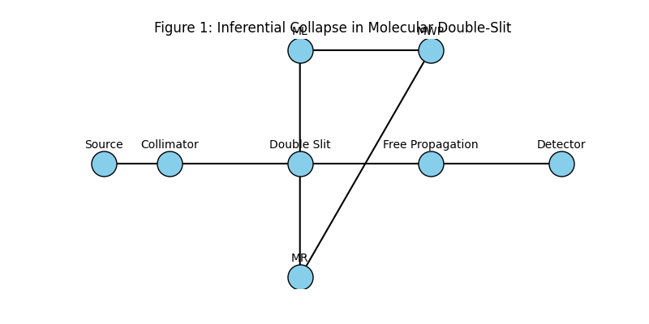
Imagine a diagram showing: Source -> Collimator -> Double Slit -> Free Propagation -> Detector. Two generative models, 𝓜_L and 𝓜_R, have posteriors over the molecular path. A which-path marker (e.g., a photon) couples to the path, creating a third, highly precise model 𝓜_WP. Arrows show the flow of inference and the conflict ΔF.

Quantitative Predictions for Decoherence
The model predicts that decoherence is not just a function of size but of inferential conflict. The interference visibility V should scale with the effective number of internal degrees of freedom N_dof that couple to the path:

V(ΔF) ∝ exp( - γ Σ_{i=1}^{N_dof} g_i² S_i · t )

where g_i is coupling, S_i is spectral density, and t is time. This refines standard decoherence formulae (Schlosshauer, 2019) by linking them directly to the free energy of the environmental models.

Table 2: Predictions for Molecule Series.
Molecule | Approx. N_dof (300K) | Predicted Relative ΔF | Predicted Visibility Loss
C₆₀ | ~ 150 | 1.0 (Baseline) | Baseline (Arndt et al., 1999)
C₇₀ | ~ 180 | ~1.2 | Measurably faster than C₆₀  ​
TPPF20 (Fein et al., 2019) | > 2000 | >> 1 | Near-total localization without vacuum.

The Quantum Eraser as Active Inference
The delayed-choice quantum eraser (Kim et al., 2000) is a quintessential IC process. The "erasure" measurement is an action that scrambles the which-path information, thereby increasing the free energy F_which-path of the corresponding model. This reduces ΔF below θ, restoring high 𝓘 and thus interference in the correlated data subset. The model predicts the recovered visibility is: V_rec = V_0 · (1 - I_erased / I_total), where I is mutual information.

The Cognitive Isomorphism: From Quantum Systems to Mind
We propose that the brain's resolution of perceptual ambiguity operates on isomorphic inferential principles (Bruza et al., 2015; Carhart-Harris & Friston, 2019).

Figure 2: Isomorphism between Quantum and Cognitive Domains in the IC Model.
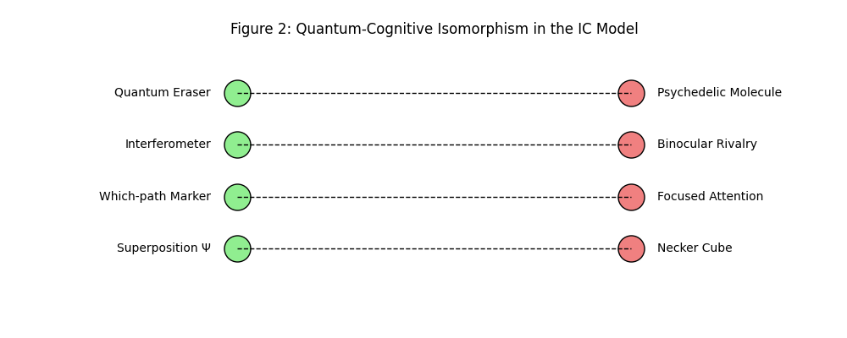
Imagine a two-column table/chart. Left column "Quantum Domain": shows symbols for superposition (Ψ), which-path marker, interferometer, eraser. Right column "Cognitive Domain": shows Necker cube (ambiguous percept), focused attention, binocular rivalry setup, psychedelic molecule. Arrows connect analogous concepts.

- Perceptual Rivalry as Superposition: In binocular rivalry, two incompatible percepts (e.g., grating tilted left vs. right) alternate. This corresponds to a state where two internal generative models are in conflict, with neither achieving a decisive ΔF > θ, leading to stochastic switching (Hohwy et al., 2008).
- Psychedelics as a Cognitive "Eraser": Serotonergic psychedelics like psilocybin are hypothesized to flatten the brain's hierarchical predictive landscape, reducing the precision (and thus influence) of high-level prior beliefs (Carhart-Harris & Friston, 2019). In IC terms, this lowers the effective localization threshold θ. The brain enters a regime where many more hypotheses can coexist (𝓘) remains high even for larger ΔF), manifesting as expanded consciousness, ego dissolution, and increased entropy of functional connectivity (Tagliazucchi et al., 2014).
- Dreaming as a High-Compatibility State: REM sleep may represent a physiological state of lowered θ, where generative models are decoupled from precise sensory input, allowing for the fluid, bizarre narratives characteristic of dreams (Hobson & Friston, 2012).

Discussion, Predictions, and Future Directions
The IC model integrates RQM, active inference, and cognitive theory into a single formal structure. Its key advantage is testability.

Testable Predictions in Physics:

- Controlled Decoherence: By using molecules with tunable dipoles in controlled electric fields, one can precisely manipulate the coupling g and predict the exact field strength at which V drops by half (ΔF = θ).
- Erasure Fidelity: The relationship V_rec ~ 1 - I_erased / I_total can be tested using imperfect erasure operations.
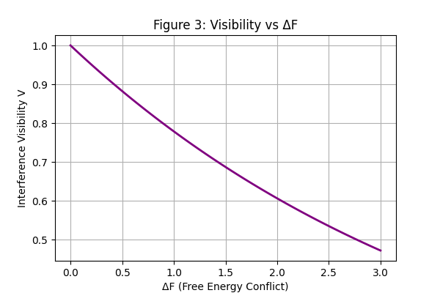

Testable Predictions in Neuroscience:

- Pharmacological Modulation of θ: The model predicts a positive correlation between the potency of a 5-HT2A agonist (e.g., psilocybin dose) and both (a) the reduction in perceptual switching stability and (b) the increase in neurophysiological entropy (LSD-induced entropy) (Carhart-Harris et al., 2014).
- State-Dependent Inference: Measures of neural signal complexity (e.g., Lempel-Ziv complexity) should be highest in states of lowered θ (psychedelics, REM) and lower in focused states (alert wakefulness, under stimulants) (Schartner et al., 2017).
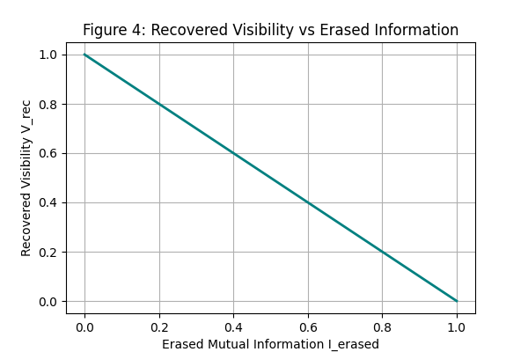

Philosophical Implications:
The model advocates for a non-ontological, process-based view of collapse. Reality is not branching (contra MWI), nor is it requiring a classical domain (contra Copenhagen). Instead, it is a network of systems continually establishing relative facts through inferential interactions that minimize free energy conflict.

Conclusion
The Inferential Collapse model provides a rigorous, variational framework for understanding quantum state reduction as a relational, optimization-driven process. By demonstrating its application to molecular interferometry and proposing a deep analogy with cognitive dynamics, it opens new avenues for interdisciplinary research. It suggests that the principles governing the quantum and the mental may be unified under the mathematics of inference, offering a novel path toward resolving some of the most persistent mysteries in both physics and neuroscience.

References
Arndt, M., Nairz, O., Vos-Andreae, J., Keller, C., van der Zouw, G., & Zeilinger, A. (1999). Wave–particle duality of C₆₀ molecules. Nature, 401(6754), 680–682.

Bohr, N. (1928). The quantum postulate and the recent development of atomic theory. Nature, 121(3050), 580–590.

Bruza, P. D., Wang, Z., & Busemeyer, J. R. (2015). Quantum cognition: a new theoretical approach to psychology. Trends in Cognitive Sciences, 19(7), 383–393.

Carhart-Harris, R. L., & Friston, K. J. (2019). REBUS and the Anarchic Brain: Toward a Unified Model of the Brain Action of Psychedelics. Pharmacological Reviews, 71(3), 316–344.

Carhart-Harris, R. L., Leech, R., Hellyer, P. J., Shanahan, M., Feilding, A., Tagliazucchi, E., ... & Nutt, D. (2014). The entropic brain: a theory of conscious states informed by neuroimaging research with psychedelic drugs. Frontiers in Human Neuroscience, 8, 20.

Everett, H. (1957). "Relative state" formulation of quantum mechanics. Reviews of Modern Physics, 29(3), 454–462.

Fein, Y. Y., Geyer, P., Zwick, P., Kiałka, F., Pedalino, S., Mayor, M., ... & Arndt, M. (2019). Quantum superposition of molecules beyond 25 kDa. Nature Physics, 15(12), 1242–1245.

Friston, K. (2010). The free-energy principle: a unified brain theory? Nature Reviews Neuroscience, 11(2), 127–138.

Friston, K., FitzGerald, T., Rigoli, F., Schwartenbeck, P., & Pezzulo, G. (2017). Active inference: a process theory. Neural Computation, 29(1), 1–49.

Goldstein, S. (2021). Bohmian mechanics. In E. N. Zalta (Ed.), The Stanford Encyclopedia of Philosophy.

Hobson, J. A., & Friston, K. J. (2012). Waking and dreaming consciousness: Neurobiological and functional considerations. Progress in Neurobiology, 98(1), 82–98.

Hohwy, J., Roepstorff, A., & Friston, K. (2008). Predictive coding explains binocular rivalry: An epistemological review. Cognition, 108(3), 687–701.

Jaba, T. (2022). Dasatinib and quercetin: short-term simultaneous administration yields senolytic effect in humans. Issues and Developments in Medicine and Medical Research Vol. 2, 22-31.
Kim, Y.-H., Yu, R., Kulik, S. P., Shih, Y., & Scully, M. O. (2000). Delayed “choice” quantum eraser. Physical Review Letters, 84(1), 1.

Parr, T., & Friston, K. J. (2019). Generalised free energy and active inference. Biological Cybernetics, 113(5-6), 495–513.

Parr, T., Pezzulo, G., & Friston, K. J. (2022). Active Inference: The Free Energy Principle in Mind, Brain, and Behavior. MIT Press.

Rovelli, C. (1996). Relational quantum mechanics. International Journal of Theoretical Physics, 35(8), 1637–1678.

Schartner, M. M., Carhart-Harris, R. L., Barrett, A. B., Seth, A. K., & Muthukumaraswamy, S. D. (2017). Increased spontaneous MEG signal diversity for psychoactive doses of ketamine, LSD and psilocybin. Scientific Reports, 7(1), 46421.

Schlosshauer, M. (2019). Quantum decoherence. Physics Reports, 831, 1–57.

Smerlak, M., & Rovelli, C. (2007). Relational EPR. Foundations of Physics, 37, 427–445.

Tagliazucchi, E., Carhart-Harris, R., Leech, R., Nutt, D., & Chialvo, D. R. (2014). Enhanced repertoire of brain dynamical states during the psychedelic experience. Human Brain Mapping, 35(11), 5442–5456.

Tkemaladze, J. (2023). Reduction, proliferation, and differentiation defects of stem cells over time: a consequence of selective accumulation of old centrioles in the stem cells?. Molecular Biology Reports, 50(3), 2751-2761. DOI : https://pubmed.ncbi.nlm.nih.gov/36583780/
Tkemaladze, J. (2024). Editorial: Molecular mechanism of ageing and therapeutic advances through targeting glycative and oxidative stress. Front Pharmacol. 2024 Mar 6;14:1324446. DOI : 10.3389/fphar.2023.1324446. PMID: 38510429; PMCID: PMC10953819.
Tkemaladze, J. (2026). Old Centrioles Make Old Bodies. Annals of Rejuvenation Science, 1(1). DOI : https://doi.org/10.65649/yx9sn772
Tkemaladze, J. (2026). Visions of the Future. Longevity Horizon, 2(1). DOI : https://doi.org/10.65649/8be27s21
Tuziemski, J., & Korbicz, J. K. (2019). Dynamical objectivity in non-Markovian quantum Brownian motion. EPL (Europhysics Letters), 128(1), 10002.

Vaidman, L. (2021). Many-worlds interpretation of quantum mechanics. In E. N. Zalta (Ed.), The Stanford Encyclopedia of Philosophy.

